**Lab 03 - Configure and create multilingual copilots**

**Lab Type** – Instructor Led

**Duration** – 25 minutes

**Objective:**

In this lab, we will create a multilingual copilot.

Multilingual copilots are copilots that can communicate with customers in different languages while keeping all the content in a single copilot. In many cases, they can automatically detect the desired language based on the copilot user's web browser setting and respond in the same language, providing a more personalized and engaging experience for customers.

**Note**

Multilingual copilots are not supported for the following scenarios:

* Microsoft Copilot Studio classic bots
* Voice bots with Dynamics Omnichannel

# Exercise 1: Configuring a multilingual copilot

When a copilot is initially created, it's created with a primary language.

1. If not already logged into your lab tenant credentials from the previous lab, from an in-private or incognito browser, open the url - [https://copilotstudio.microsoft.com/.](https://copilotstudio.microsoft.com/) Login using the credentials from the lab instructor. Click on your copilot **Customer service**.

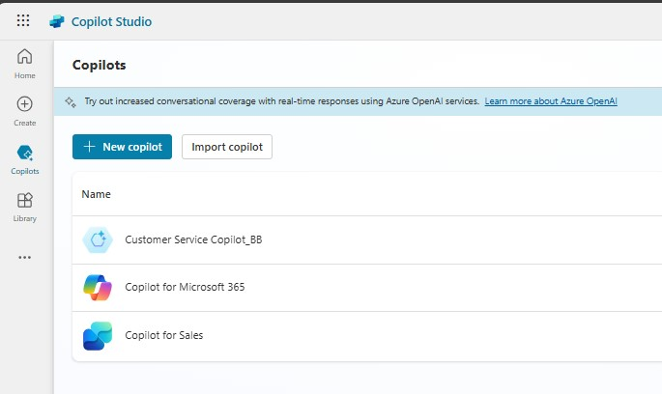

1. With a copilot open, click on the **Settings** button in the upper right corner.

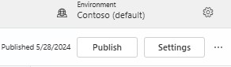

1. Click on **Languages** then **+ Add Languages**.

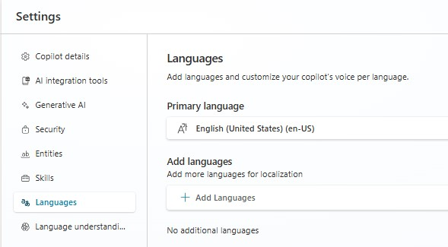

1. In the flyout on the right, Select **Spanish** language and then select **Add Languages**.

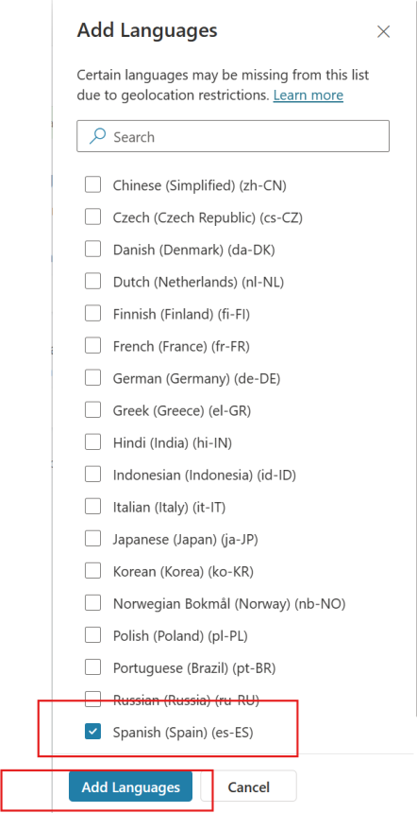

3. A success message is displayed and the selected language are listed in the as **Secondary language** in the Languages page.

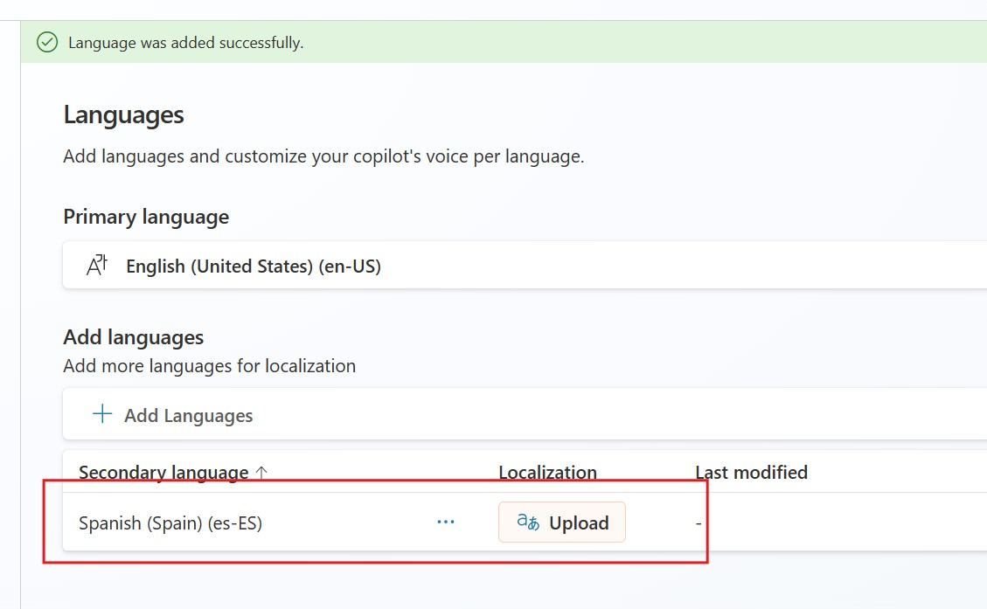

**Note**

You can add as many secondary languages as desired to the copilot, if they are in the list of supported languages. However, or this lab, please choose Spanish as we have translated file for Spanish only.

# Exercise 2: Managing localization in a multilingual copilot

**Note:**

All copilot topic and content editing must be done in the copilot's primary language. To edit the copilot's secondary language to localize the strings, you must use the steps in this section.

Once the copilot strings are localized and uploaded to the copilot as described here, you can see the localized content in the authoring canvas by switching the language in the **Test copilot** window. We will walk you through the steps but have a file for you to use during the labs so you don’t have to translate the text during the lab.

1. With the copilot **Customer service** open, expand **Languages** from the left navigation pane, and select **Upload** button next to Spanish language.

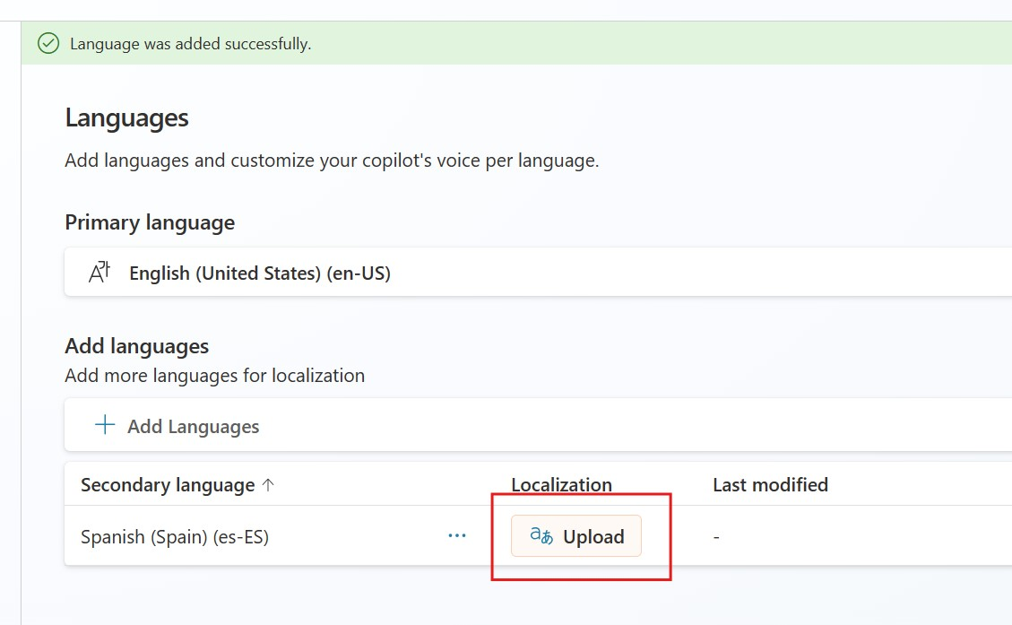

1. On the **Update localizations** flyout, select **Download localization file as JSON** to download the current localization file for that language.

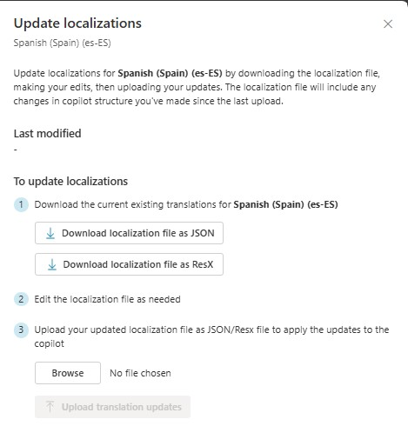

1. **The following steps are for your information** only as we have already created a file with the translation for you to utilize in the labs.

|  |  |
| --- | --- |
| • | Open the downloaded file and make a copy of it. |

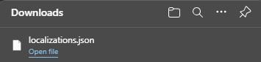

|  |  |
| --- | --- |
| • | Rename the copied version of the file as **localizations-**  **<language>.json**(Replace the **language** with the language you are using. It is **Spanish** in this case) . |
| • | Open the file and replace the primary language strings with the appropriate translated text similar to the below snippet and save the file. |
| • | Make sure all the copilot’s messages that are in English are updated with the secondary language selected. |

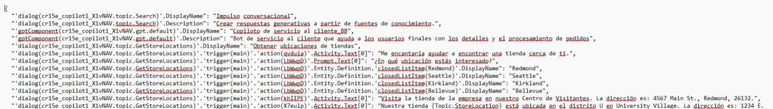

1. For the purpose of this lab, **Open** **the downloaded JSON file in Notepad** and **copy** your bot name from line 1 (first word within () before **.topic.Search**), as shown below. We will use this to update the Language_Spanish.txt file next.

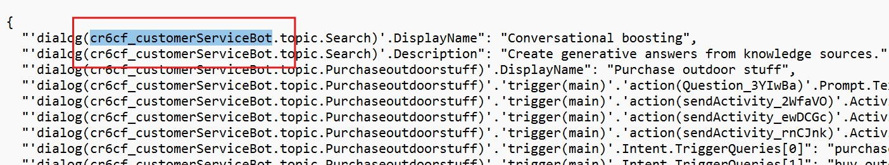

1. Open **Lab Resources** folder and open **Language_Spanish.txt** file. Carefully replace all instances of <YOURBOTNAME> with the bot name you copied in last step - **cr6cf_customerServiceBot. (**In Notepad,click **Edit** > **Replace** option to replace all at once)

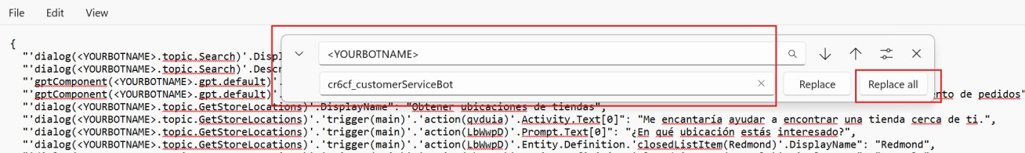

1. Click **File > Save** to save the file as **Language_Spanish.JSON** (Add **.JSON** at the end in file name to ensure this file is saved as JSON file on your computer)

1. Return to the **Languages** page, select Upload for the Spanish secondary language.



1. In step 3, click on **Browse** and upload the **localization-Spanish.json** file that you just updated.

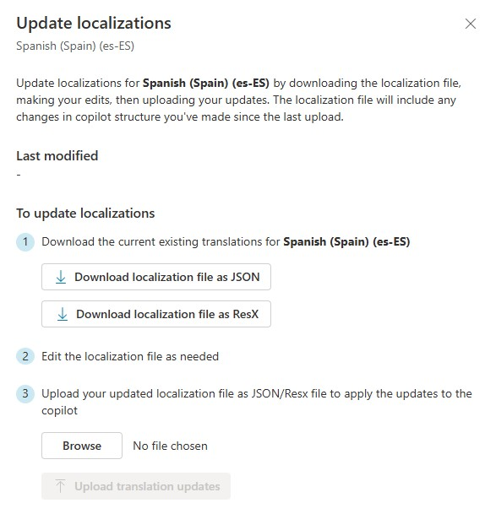

1. Click on **Upload translation updates**.

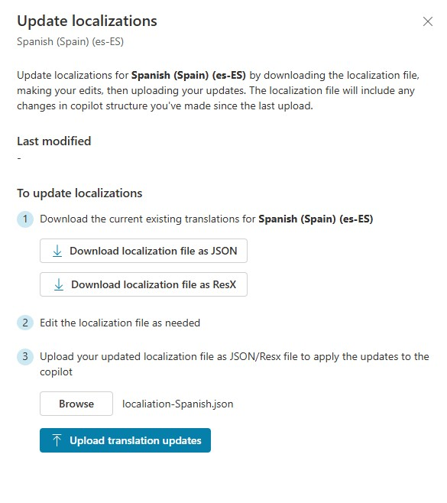

1. Confirm you want to override all past localizations by clicking on **Update localizations.**

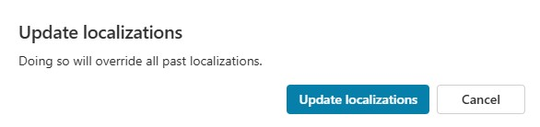

1. A **Localizations updated Successfully** message appears. Click on **Close** to close the Update localizations page.

12.

Close the Settings window.

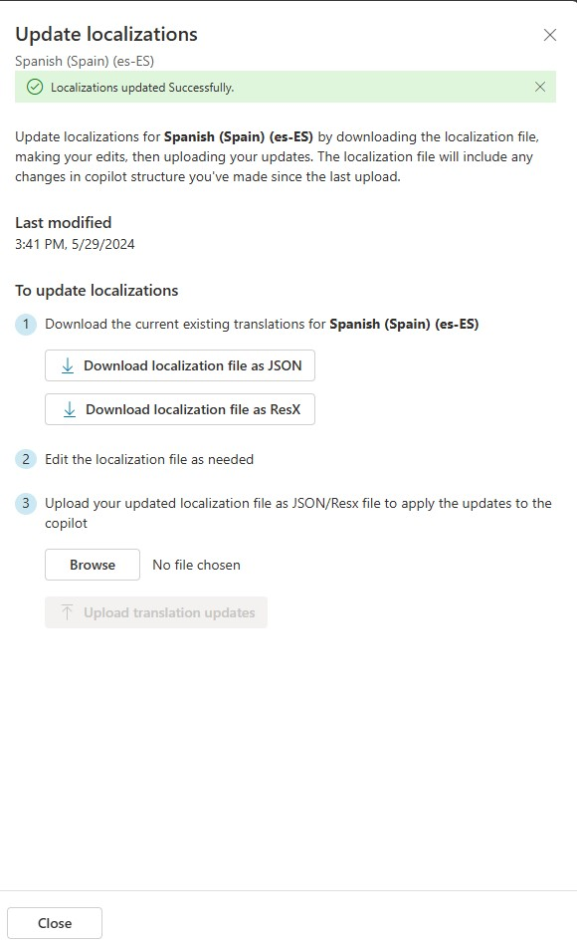

# Exercise 3: Testing a multilingual copilot

1. Click on **Test** in the upper right.

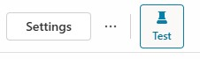

1. Click on the more **(…)**, then **Language** and select secondary language - **Spanish**.

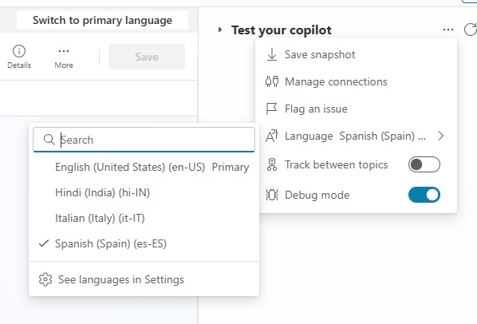

1. The test copilot will reload itself, this time using the selected secondary language. The authoring canvas shows the secondary language.

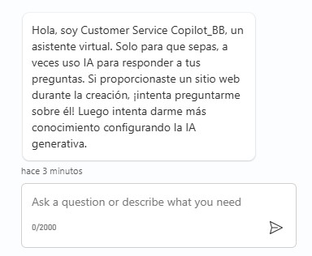

1. Type and send **Ola** (Hello in Spanish) to see the bot respond in Spanish.

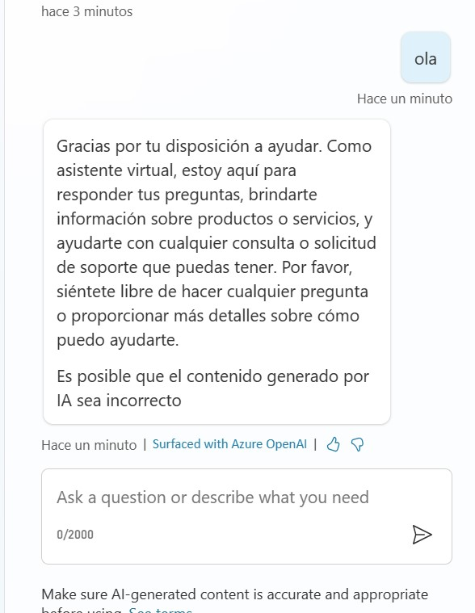

1. Lastly, we will need to remove the Spanish Language from languages window as Generative AI is only supported in English as of now. Go to **Languages page** and **remove** the Spanish language.

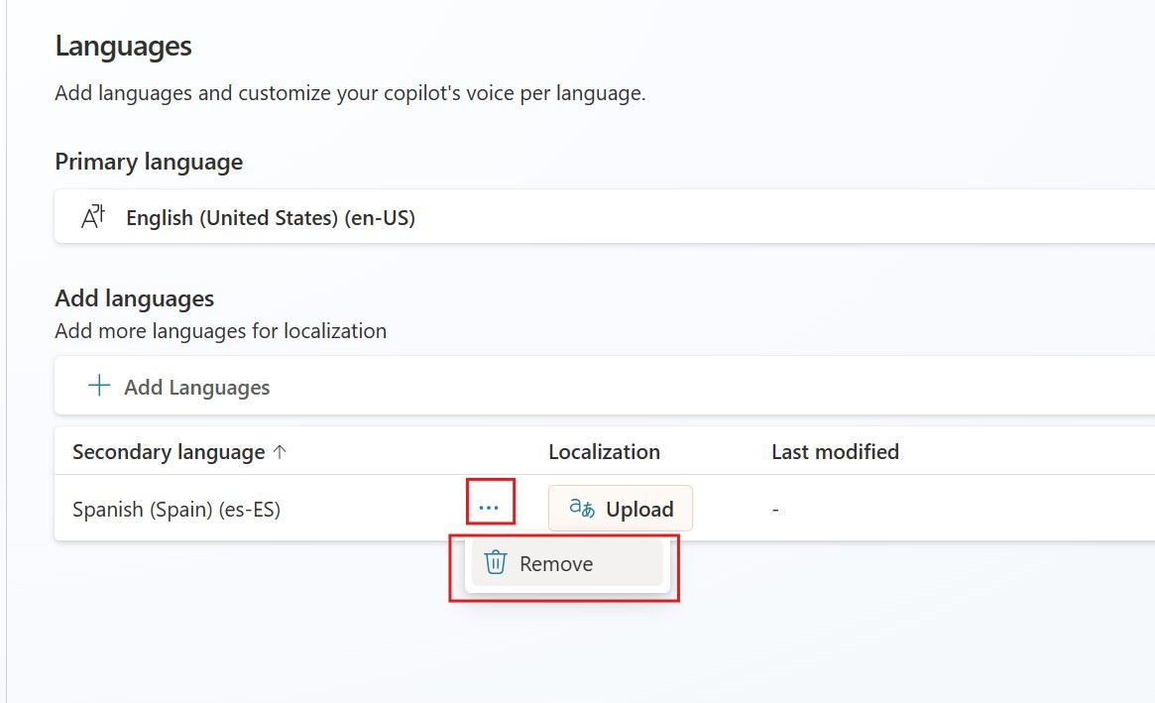

1. **Test** your Copilot to ensure the welcome message is in English.

**|** P a g e

# Multilingual copilot behavior for languages that are not configured

If a copilot user has their browser configured for a language that is not configured in the copilot through the steps above, the copilot will always fallback to its primary language (the language the copilot was created in originally). The copilot's primary language cannot be changed after copilot creation.

# Multilingual copilot behavior for missing translations

If the copilot author makes a change to the copilot in the primary language and doesn't upload the translations, the copilot will show the untranslated changes in the copilot's primary language. This leads to a confusing dual-language experience. Always make sure the translations are up-to-date after making changes to the copilot in the primary language.

**Summary:**

In this lab, we have learnt on how to configure multilingualism, update the localizations and test it in copilot.

**|** P a g e